**Malawi country profile**

Published

2 July

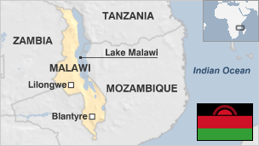

**Malawi, a largely agricultural country, is making efforts to overcome decades of underdevelopment.**

For the first 30 years of independence Malawi was run by an authoritarian and quixotic President Hastings Kamuzu Banda, but democratic institutions have taken hold since he relinquished power in the mid-1990s.

Most Malawians rely on subsistence farming, but the food supply situation is precarious because of the climate.

In recent years the country has achieved significant economic growth.

* Read more [country profiles](http://news.bbc.co.uk/1/hi/country_profiles/) - Profiles by [BBC Monitoring](http://bbc.co.uk/monitoring)

**President: Lazarus Chakwera**

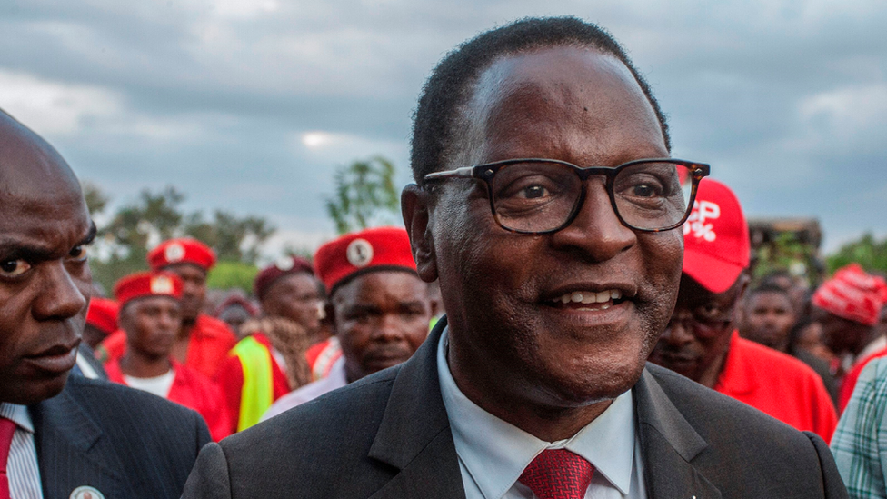image copyrightGetty Images

Mr Chakwera was sworn in as president in June 2020, ending a period of turmoil after annulled elections the previous year.

A Christian preacher and theologian, he beat the incumbent president Peter Mutharika in a re-run of the 2019 poll, which the courts decided had seen widespread irregularities.

President Chakwera has pledged to try to unite the country after the bruising political stand-off.

**MEDIA**

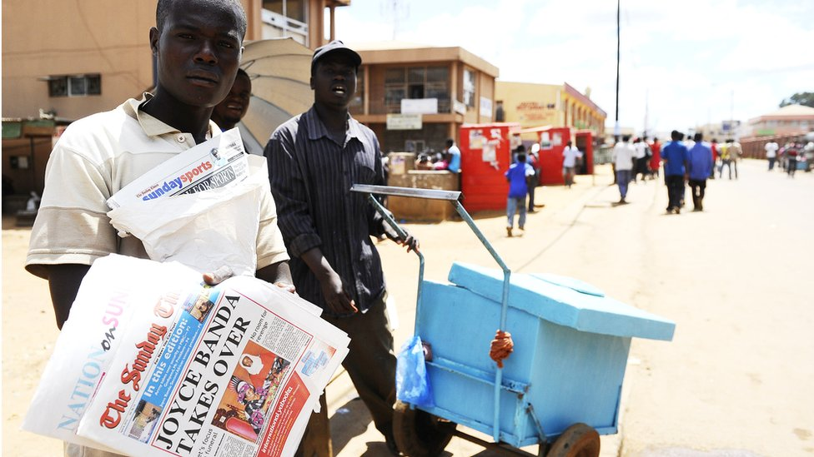image copyrightGetty Images

Radio is the leading medium and state-run MBC is the main national broadcaster.

The freedom to inform has improved and the number of abuses against journalists has fallen dramatically, says Reporters Without Borders.

# Malawi profile

Published

19 March 2019

## A chronology of key events:

**1480** - Bantu tribes unite several smaller political states to form the Maravi Confederacy which at its height includes large parts of present-day Zambia and Mozambique plus the modern state of Malawi.

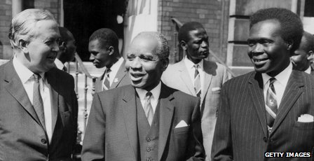image copyrightGetty Images

image captionDr Hastings Banda (centre) led Malawi from independence in 1963 until he fell ill in 1993.

**17th century** - Portuguese explorers arrive from the east coast of present-day Mozambique.

**1790-1860** - Slave trade increases dramatically.

**1850** - Scottish missionary David Livingstone's exploration of the region paves the way for missionaries, European adventurers, traders.

**1878** - Livingstonia Central African Mission Company from Scotland begins work to develop a river route into Central Africa to enable trade.

**1891** - Britain establishes the Nyasaland and District Protectorate.

**1893** - Name is changed to the British Central African Protectorate. White European settlers are offered land for coffee plantations at very low prices. Tax incentives force Africans to work on these plantations for several months a year, often in difficult conditions.

**1907** - British Central African Protectorate becomes Nyasaland.

**1915** - Reverend John Chilembwe leads a revolt against British rule, killing the white managers of a particularly brutal estate and displaying the head of one outside his church. He is shot dead by police within days.

**1944** - Nationalists establish the Nyasaland African Congress.

**1953 23 October** - Despite strong opposition from the Nyasaland African Congress and white liberal activists, Britain combines Nyasaland with the Federation of Northern and Southern Rhodesia (now Zambia and Zimbabwe respectively).

**1958** - Dr Hastings Kamuzu Banda, "the black messiah", denounces the federation and returns from the US and the UK, where he has been studying, to lead the Nyasaland African Congress.

**1959** - Violent clashes between the Congress supporters and the colonial authorities lead to the banning of the organisation. Many leaders, including Banda, are arrested and a state of emergency is declared.

Malawi Congress Party is founded as a successor to the Nyasaland African Congress.

**1960** - Banda is released from Gwelo prison and attends talks in London with the British government on constitutional reform.

**1961** - Elections held for a new Legislative Assembly. Banda's Malawi Congress Party wins 94% of the vote.

**1963** - Territory is granted self-government as Nyasaland and Banda is appointed prime minister.

## Independence

**1964 6 July** - Nyasaland declares independence as Malawi.

**1966 6 July** - Banda becomes president of the Republic of Malawi. The constitution establishes a one-party state. Opposition movements are suppressed and their leaders are detained. Foreign governments and organisations raise concerns about human rights.

**1971** - Banda is voted president-for-life.

**1975** - Lilongwe replaces Zomba as capital.

**1978** - First elections since independence. All potential candidates must belong to the Malawi Congress Party and be approved by Banda. He excludes many of them by submitting them to an English test.

**1980s** - Several ministers and politicians are killed or charged with treason. Banda reshuffles his ministers regularly, preventing the emergence of a political rival.

**1992** - Catholic bishops publicly condemn Banda, sparking demonstrations. Many donor countries suspend aid over Malawi's human rights record.

**1993** - President Banda becomes seriously ill.

Voters in a referendum reject the one-party state, paving the way for members of parties other than the Malawi Congress Party to hold office.

## Muluzi elected

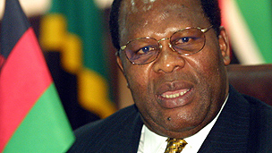image copyrightGetty Images

image captionBakili Muluzi won elections and replaced long-term leader Hastings Banda

**1994** - Presidential and municipal elections: Bakili Muluzi, leader of the United Democratic Front, is elected president. He immediately frees political prisoners and re-establishes freedom of speech.

Banda announces his retirement from politics.

**1997** - Banda dies in hospital in South Africa where he is being treated for pneumonia.

**1999** - President Muluzi is re-elected for a second and final five-year term.

**2000** - World Bank says it will cancel 50% of Malawi's foreign debt.

**2002** - Drought causes crops to fail across southern Africa. Government is accused of worsening crisis through mismanagement and corruption, including selling off national grain reserves before drought struck.

**2002** September - Railway line linking central Malawi and Mozambican port of Nacala reopens after almost 20 years, giving access to Indian Ocean.

**2004** May - Bingu wa Mutharika wins presidency.

Government says it will provide free anti-viral drugs to Aids sufferers.

**2005** January - Three UDF officials are charged with treason after carrying guns to a meeting with President Mutharika. The president later pardons the trio.

## Mutharika's struggles

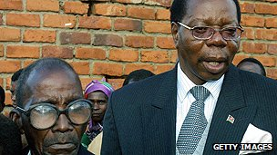image copyrightGetty Images

image captionPresident Mutharika, right, was elected to a second term but died in office

**2005** February - President Mutharika resigns from the UDF over what he says is its hostility to his anti-corruption campaign. He forms the Democratic Progressive Party (DPP).

**2005** June - President Mutharika survives an impeachment motion backed by the UDF. The speaker of parliament dies after collapsing during angry exchanges over the motion.

**2005** November - Agriculture minister says five million people need food aid as Malawi bears the brunt of failed crops and a regional drought.

**2006** April - Vice-President Cassim Chilumpha is arrested and charged with treason.

**2006** July - Ex-president Bakili Muluzi is arrested on corruption charges.

**2006** October - Controversy as American singer Madonna is given temporary rights to adopt a Malawian baby.

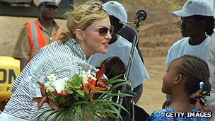image copyrightGetty Images

image captionPop star Madonna adopted two Malawian children

**2007** May - Malawi begins exporting 400,000 tonnes of maize to Zimbabwe, after producing a surplus in 2006.

**2008 January** - Malawi ends diplomatic relations with Taiwan, switching allegiance to China.

**2008** May - Several opposition figures and ex-security chiefs are arrested after President Mutharika accuses his predecessor, Bakili Muluzi, of plotting to depose him.

## Mutharika re-elected

**2009** May - President Mutharika wins second term in election.

**2010** May - A gay couple is convicted and jailed for breaching anti-homosexuality laws, sparking international condemnation. The two men are given a presidential pardon and released.

**2010** August - New national flag introduced amid controversy. First local elections in a decade postponed again.

**2010** October - Diplomatic row with Mozambique over a new waterway connecting Malawi with the Mozambique coast. Mozambique impounds first barge to use new route.

**2010** November - Protests against a bill setting the retirement age at between 55 and 60, higher than average life expectancy.

**2011** March - President Mutharika angers opposition parties by calling on members of his Democratic Progressive Party at a rally to beat up those who have insulted him.

**2011** May - Malawi expels British high commissioner over a leaked diplomatic cable in which the envoy describes President Mutharika as increasingly autocratic.

**2011** July **-** Anti-government protests leave 19 people dead. Britain halts all aid to Malawi, accusing the government of mishandling the economy and failing to uphold human rights.

**2012** April - President Mutharika dies, is succeeded by vice-president Joyce Banda. The following month she devalues the kwacha currency by a third to satisfy International Monetary Fund requirements to restore funding. This prompts panic buying of basic goods.

**2012** October - Malawi asks the African Union to intervene in a border dispute with Tanzania over Lake Malawi, which is potentially rich in oil and gas. Malawi disputes Tanzania's claim to half the lake.

**2013** October - President Banda sacks cabinet amid allegations of widespread corruption. Senior finance ministry official Paul Mphwiyo, an anti-corruption crusader, was shot and wounded in September.

**2014** January - First of 70 defendants appear in court over the so-called Cashgate affair - the country's biggest corruption scandal so far.

**2014** May - Peter Mutharika, the brother of late President Bingu wa Mutharika, wins presidential election.

**2014** April - President Peter Mutharika signs into law raising the marrying age to 18, following a campaign against Malawi's's rate of child marriage - one of the world's highest.

**2019** March - Cyclone Idai causes extensive flooding and loss of life in eastern districts.

**2020** June - Christian preacher and theologian Lazarus Chakwera beats Peter Mutharika in a re-run of the 2019 presidential election, which the courts decided had seen widespread irregularities.